DHE EMSAS Submission Guide
  - Updated 08/06/2012
Contents
State Report Manager – Enhanced Feedback Reports 1
Overview 1
Release Schedule: 1
Logging In: 2
Submitting a Trial (data) 2
Reviewing Errors & Warnings 2
Difference between Errors & Warnings 4
Editing the Data for Single Record 4
Revalidating Your Data 4
General Tips 5
Certifying Your Data 6

State Report Manager – Enhanced Feedback Reports

Overview
The State Report Manager, or SRM, is a new tool that MDHE will roll out this fall for submitting EMSAS data to the state. SRM is an online application that provides detailed, real-time feedback about potential data issues. It also allows you to edit individual records, download your data file (especially useful after editing), and extract a report in Excel that summarizes potential data issues. SRM is expected to replace FTP as the method for providing EMSAS files to the state in the future.

Release Schedule:
Sept 15th – Term Registration
Sept 15th – Fall Enrollment
Oct 1st – Degree Completion
File layouts, business rules (information about what triggers each error or warning), and other information is available at http://www.dhe.mo.gov/data/emsas/index.php
For many institutions, SRM will only require minor changes to the data files submitted in previous years. Specifically, files must be comma or tab-delimited format with a header row that contains the field names.

Logging In:
- Login by going to: http://dhe.mo.gov/data/srm

Submitting a Trial (data)
- “Click Run a Trial”
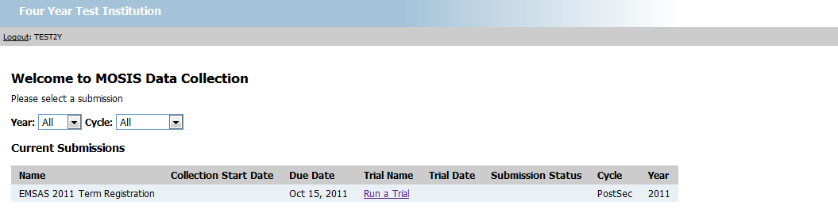
- Find the file by clicking “Browse”
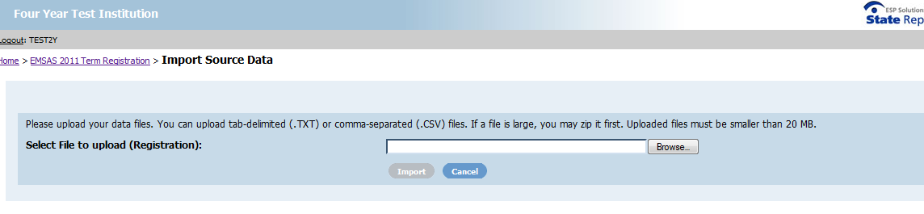
- Click “Import”
- Wait for the system to process
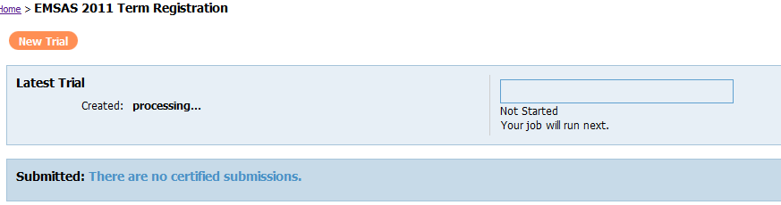

Reviewing Errors & Warnings
- Submit a trial
- Click on the “Errors”
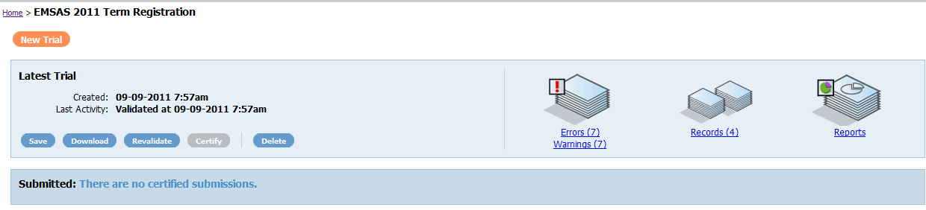
- Errors and warnings will be displayed
- Now click on the error of interest
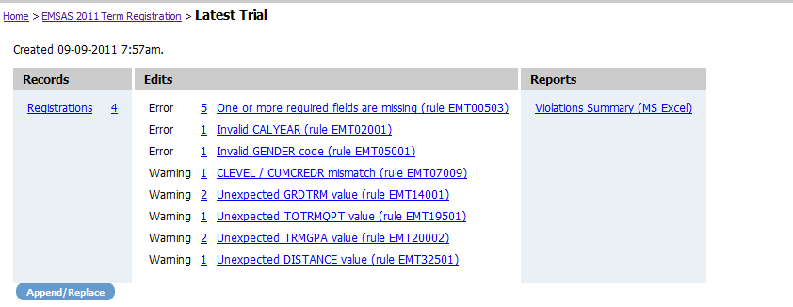
- Records with violations will be displayed
- Click on “View” next to a record
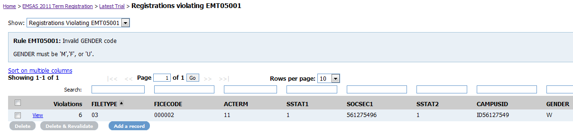
- Note- For fields which have a code set you will see a brief explanation of the provided code
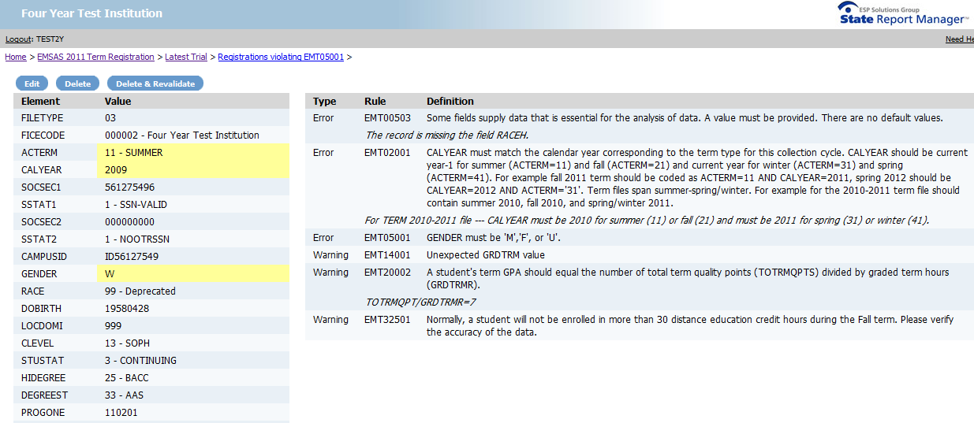

Difference between Errors & Warnings
- Warning – allowed, but please exercise your best judgment
- Errors – not allowed. One way or another, these will need to be cleaned up!

Editing the Data for Single Record
- Click on edit to modify the record or delete if you wish to remove the record
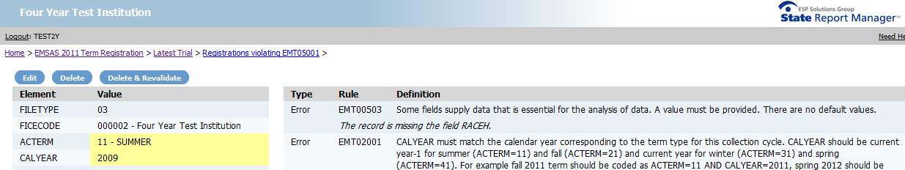
- Make your desired change(s) to the record using the drop down menus or text boxes
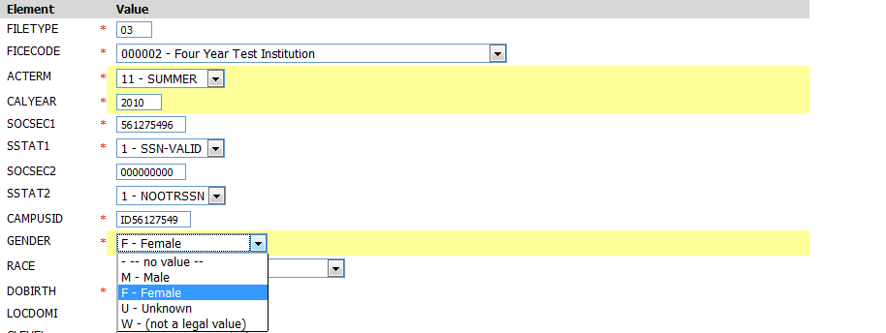
- When finished hit “Save”. The “Save” button appears as the bottom and the top of the page.
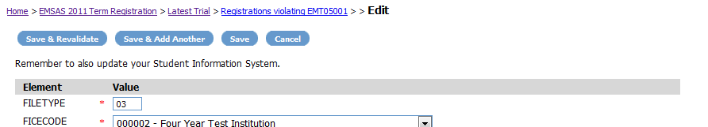

Revalidating Your Data
- Return to your trials page by clicking on the submission type link near the top of the screen. In this example you see “EMSAS 2011 Term Registration”
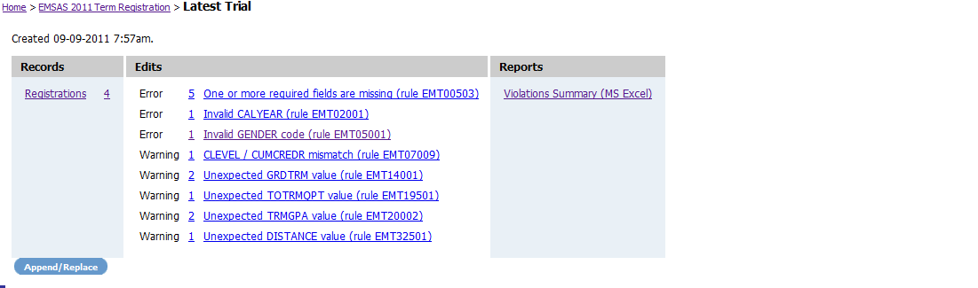
- Click on the “Revalidate” button.
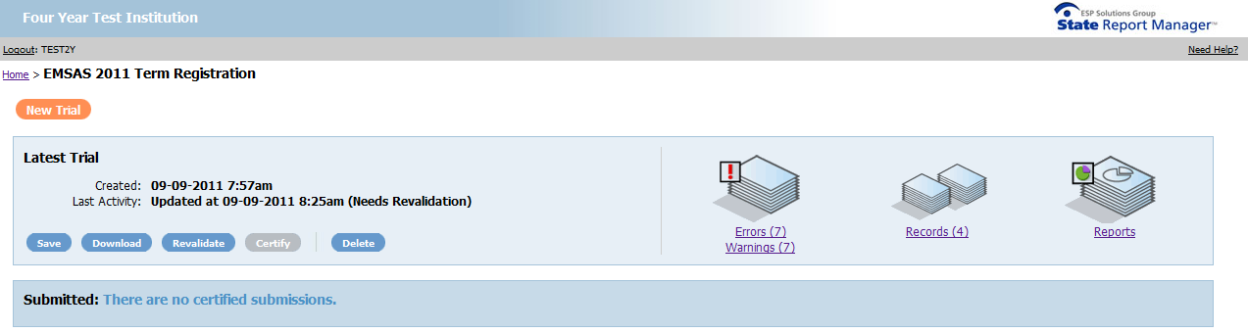
- The system will process the new file

- When finished follow the steps above in the “Reviewing Errors & Warnings” section to resolve other violations (errors and warnings).

General Tips
- Don’t use your browsers back and forward buttons, instead use the breadcrumb links
- You can review records by rule (display only records that violate that rule) or by record (you can move from one record to another, sequentially).
- Save and revalidate – revalidating means the system checks over the data another time. It is important to revalidate after making several edits.
- Once you log out you must return to http://dhe.mo.gov/data/srm . You cannot use the login page which is displayed after logging out.
- You may have only one certified trial. It is possible to overwrite certified trials as necessary up until the deadline for certifications. We will announce these deadlines as soon as they are identified.

Certifying Your Data
After submitting your data and correcting any errors you may certify your data. Certifying your data is your official transmission of data to DHE. Please contact he.research@dhe.mo.gov if you need to resubmit your certified data.

DO NOT e-mail webreplyMOSIS@dese.mo.gov

