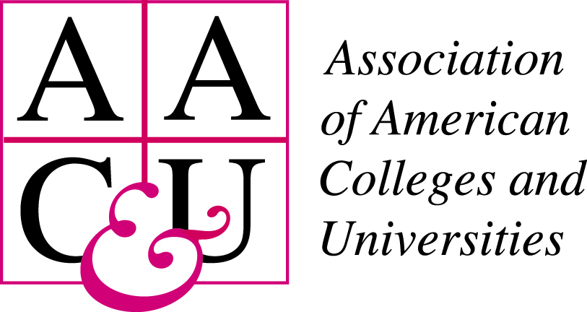

Multi-State Collaborative (MSC) to Advance Quality Student Learning
Refinement Year

MSC Sample Plan
Planning Matrix & Evaluation Tool

For institutions participating in the MSC Refinement Year, this matrix serves two purposes:
- A planning and reflection tool for institutions to use in developing sampling plans for the collection of student learning artifacts, and
- An evaluation tool for the MSC Sampling Committee to use in providing consistent feedback to participating institutions with respect to their submitted sampling plans.

Please complete the matrix below and return both the narrative and matrix to Gloria Auer gauer@sheeo.org by November 11, 2016.

The shaded cells in the matrix should be left blank. Feedback from the sampling subgroup will be entered in these cells.

Institution/Consortium:  State: | Contact Person:  Email address:

Please provide an overall description of your institution’s planned sampling process being sure to address the following questions in your narrative:
- What is your overall approach to sampling?
- How do you plan to ensure that all students in your sample meet the eligibility criteria?
- What steps do you plan to undertake in your attempt to draw a representative sample?
- Do you plan to begin with the student, course, or faculty member?
- How do you plan to incorporate sampling methods (Simple, Systematic, Stratified, other) to draw a random sample?

If your institution participated in the MSC 2015/2016 Demonstration Year, please indicate what adjustments, if any, you made to your MSC Demonstration Year sampling plan and why.

1. Sampling Method Proposed (Circle): Student Course Faculty
Thoughts, Concerns:

2. Method for Drawing a Random Sample (Circle): Simple Manual Systematic Stratified
Thoughts, Concerns:

Institutional Input |  | Y/N or unclear | Sampling Group Feedback
Option 1—Early & Late Collection. The sample will include at least 50 artifacts (maximum is 150) from first-term students or students who have 15 or fewer credits earned; and include at least 50 artifacts (maximum is 150) from students who have completed 75% of the credit hours to a degree (at least 45 credit hours at two-year institutions and at least 90 credit hours at four-year institutions) (For Oregon institutions, the credit hour numbers will be the equivalent quarter hours.)
OR
Option 2 – Late Collection Only. The sample will include at least 100 artifacts from students who have completed 75% of credit hours to degree completion (at least 45 credit hours at two-year institutions and at least 90 credit hours at four-year institutions) (maximum of 300). (For Oregon institutions the credit hour numbers, will be the equivalent quarter hours.)

The following student groups may be included in the total population of eligible students, given the criterion above holds:
- full-time and part-time students
- transfer students
- students enrolled in: day, evening, traditional, on-line, and/or hybrid/blended courses
 | The sample is likely to exceed 100 artifacts per outcome
 | The sample will be drawn from work completed by students during the fall semester 2016 or during the spring semester 2017
 | The sampling method ensures the sample will include student work drawn from more than two courses.
 | The sampling method ensures the sample will include student work drawn from more than two faculty members.
 | The sampling method ensures the sample will include student work drawn from courses in more than two disciplinary areas or para-professional or professional programs.
 | The sampling method ensures the sample will include no more than 10 artifacts from a given faculty member and/or a given course.
 | The sampling method ensures the sample will include only one artifact per student.

