June 7, 2012
9:00 a.m. – 3:30 p.m.
Courtyard by Marriott Columbia
3301 Lemone Industrial Boulevard
Columbia, MO

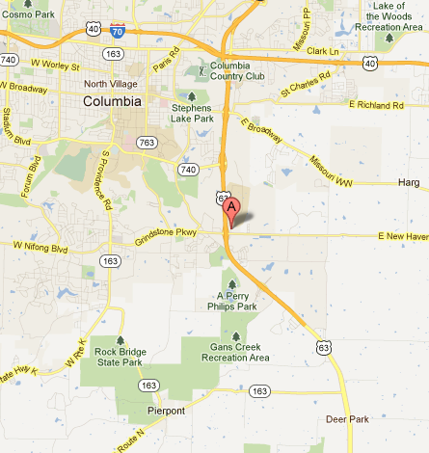

From Hwy 54
Turn on to US-63 North toward Columbia.
Follow US-63 to the MO-AC exit.
Turn right onto MO-AC/Grindstone Pkwy/New Haven Ave/Old 63 S.
Keep straight onto New Haven Ave.
Turn left onto Lemone Industrial Blvd.

From Hwy 70
Turn on to US-63 South toward Jefferson City.
Follow US-63 to the MO-AC exit.
Turn left onto MO-AC/Grindstone Pkwy/New Haven Ave/Old 63 S.
Keep straight onto New Haven Ave.
Turn left onto Lemone Industrial Blvd.

Individuals are responsible for reserving and paying for their own hotel rooms
A block of rooms are being held until May 18th at the Courtyard
at a rate of $80 for the evening of June 6.

Reservations may be made by calling the hotel directly at:
573-443-8000.
Ask for the Missouri Department of Higher Education conference rate.

For additional information contact:
Kathy Love, Public Information Officer
Missouri Department of Higher Education
573-522-1463
kathy.love@dhe.mo.gov

