GRAPHIC SUMMARY
Proprietary Sector of Missouri Postsecondary Education

2007-2008

Figure 1
Percent Enrollment by Educational Preparation, 2007
Missouri Private Career Schools vs. Out-of-State
Regionally Accredited Degree-Granting Institutions

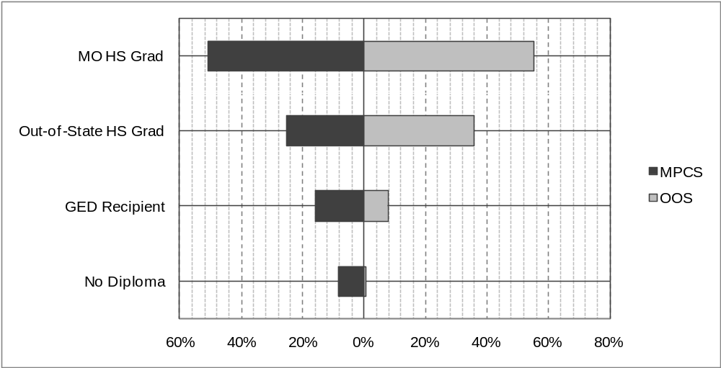

 | MO HS Grad | Out-of-State HS Grad | GED Recipient | No Diploma
MPCS | 50.7% | 25.2% | 15.9% | 8.2%
OOS | 55.3% | 36.0% | 7.9% | 0.8%

Source: Proprietary School Data System.

Note: MPCS = Missouri Private Career Schools; OOS = Out-of-State Regionally Accredited Degree-Granting Institutions.
Percentages are based on totals for the respective institution types excluding students whose level of educational preparation was unreported*. There were 560 MPCS students and 146 OOS students whose level of educational preparation was unreported.
Percentages may not sum to 100 due to rounding.
Does not include enrollment at correspondence schools.
*N_{MPCS} = 43,032; N_{OOS} = 6,379.

Figure 2
Percent Enrollment by Award Level, 2007
Missouri Private Career Schools vs. Out-of-State
Regionally Accredited Degree-Granting Institutions

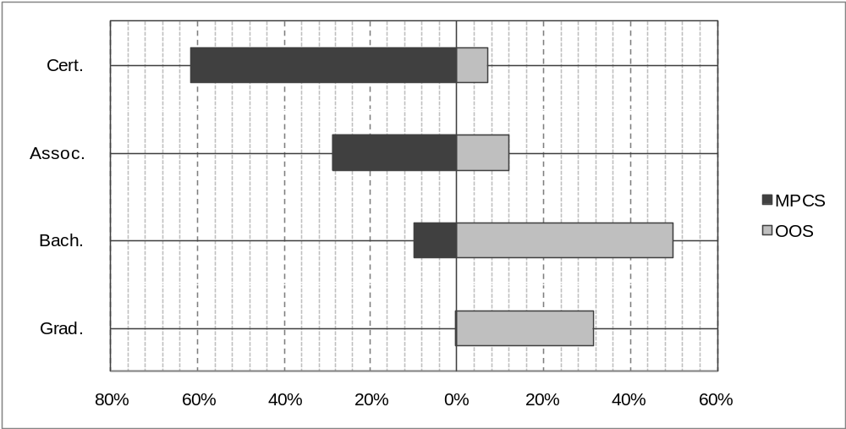
 | Cert. | Assoc. | Bach. | Grad.
MPCS | 61.4% | 28.7% | 9.9% | *0.0%
OOS | 7.0% | 11.9% | 49.8% | 31.3%

Source: Proprietary School Data System.

Note: MPCS = Missouri Private Career Schools; OOS = Out-of-State Regionally Accredited Degree-Granting Institutions.
Percentages are based on totals for the respective institution types excluding students whose award level was unreported**. There were 84 MPCS students and 28 OOS students whose award level was unreported.
Percentages may not sum to 100 due to rounding.
Does not include enrollment at correspondence schools.
*<0.05%
**N_{MPCS} = 43,508; N_{OOS} = 6,497.

Figure 3
Percent Enrollment by Gender, 2007
Missouri Private Career Schools vs. Out-of-State Regionally
Accredited Degree-Granting Institutions

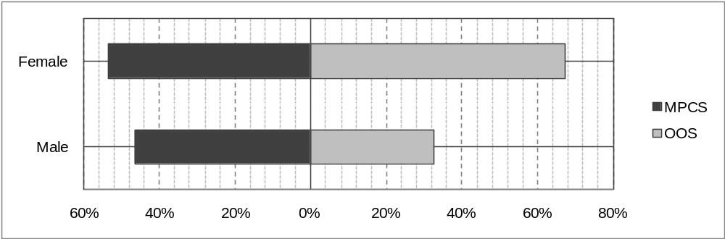
Source: Proprietary School Data System.
 | Female | Male
MPCS | 53.5% | 46.5%
OOS | 67.4% | 32.6%

Note: MPCS = Missouri Private Career Schools; OOS = Out-of-State Regionally Accredited Degree-Granting Institutions.

Percentages are based on totals for the respective institution types excluding students whose gender was unreported*. There were 1,835 MPCS students and 272 OOS students whose gender was unreported.
Percentages may not sum to 100 due to rounding.
Does not include enrollment at correspondence schools.
*N_{MPCS} = 41,757 N_{OOS} = 6,253.

Figure 4
Percent Enrollment by Age, 2007
Missouri Private Career Schools vs. Out-of-State
Regionally Accredited Degree-Granting Institutions

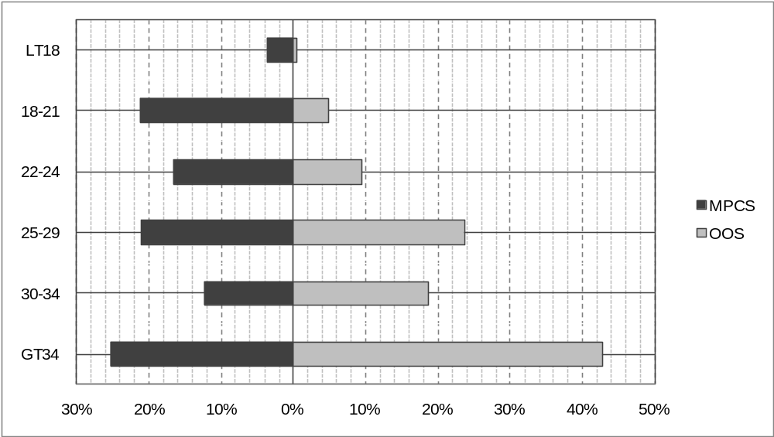
 | LT18 | 18-21 | 22-24 | 25-29 | 30-34 | GT34
MPCS | 3.6% | 21.3% | 16.6% | 21.0% | 12.3% | 25.3%
OOS | 0.4% | 4.8% | 9.6% | 23.6% | 18.7% | 42.8%

Source: Proprietary School Data System.
Note: MPCS = Missouri Private Career Schools; OOS = Out-of-State Regionally Accredited Degree-Granting Institutions.
Percentages are based on totals for the respective institution types excluding students whose age was unreported*. There were 1,816 MPCS students and 252 OOS students whose age was unreported.
Percentages may not sum to 100 due to rounding.
Does not include enrollment at correspondence schools.
*N_{MPCS} = 41,776; N_{OOS} = 6,273.
Figure 5A
Percent Enrollment by Ethnicity, 2007
Missouri Private Career Schools

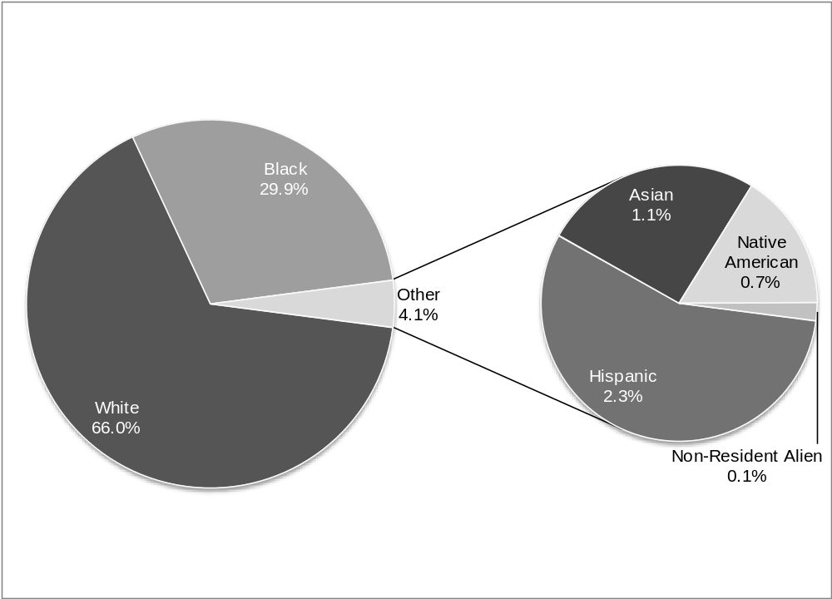
Source: Proprietary School Data System.
Note: Percentages are based on total enrollment at Missouri Private Career Schools (MPCS) excluding students whose ethnicity was unreported*. There were 2,441 MPCS students whose ethnicity was unreported.
Percentages may not sum to 100 due to rounding.
Does not include enrollment at correspondence schools.
*N_{MPCS} = 41,151.
Figure 5B
Percent Enrollment by Ethnicity, 2007
Out-of-State Regionally Accredited Degree-Granting Institutions

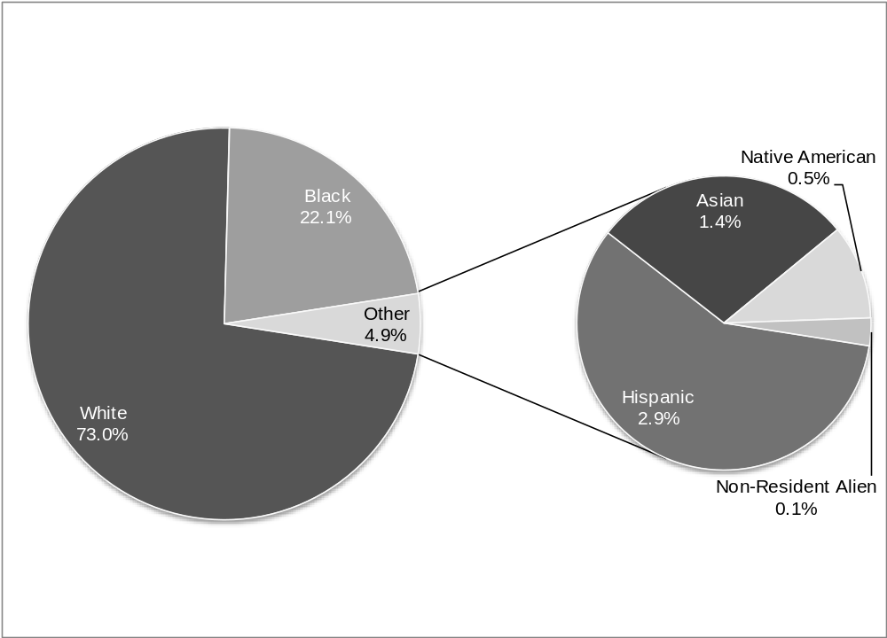
Source: Proprietary School Data System.
Note: Percentages are based on total enrollment at Out-of-State Regionally Accredited Degree-Granting Institutions (OOS) excluding students whose ethnicity was unreported*. There were 486 OOS students whose ethnicity was unreported.
Percentages may not sum to 100 due to rounding.
*N_{OOS} = 6,039.

Figure 6
Percent Enrollment by Full/Part-Time Status, 2007
Missouri Private Career Schools vs. Out-of-State
Regionally Accredited Degree-Granting Institutions

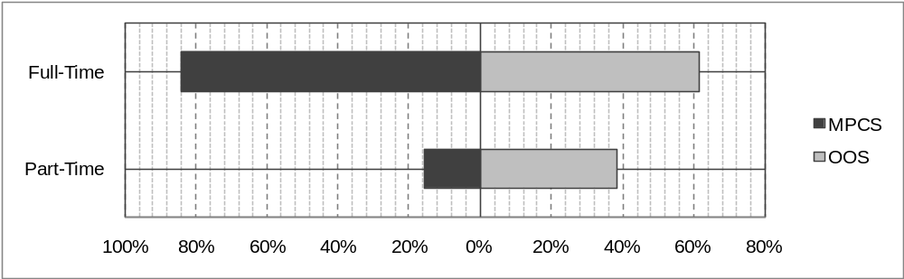
Source: Proprietary School Data System.
 | Full-Time | Part-Time
MPCS | 84.3% | 15.7%
OOS | 61.6% | 38.4%
Note: MPCS = Missouri Private Career Schools; OOS = Out-of-State
Regionally Accredited Degree-Granting Institutions.

Percentages are based on totals for the respective institution types excluding students whose enrollment status was unreported*. There were 441 MPCS students and 154 OOS students whose enrollment status was unreported.
Percentages may not sum to 100 due to rounding.
Does not include enrollment at correspondence schools.
*N_{MPCS} = 43,151; N_{OOS} = 6,371.

Figure 7A
Percent Enrollment of Missouri Residents by Region of Origin, 2007
Missouri Private Career Schools

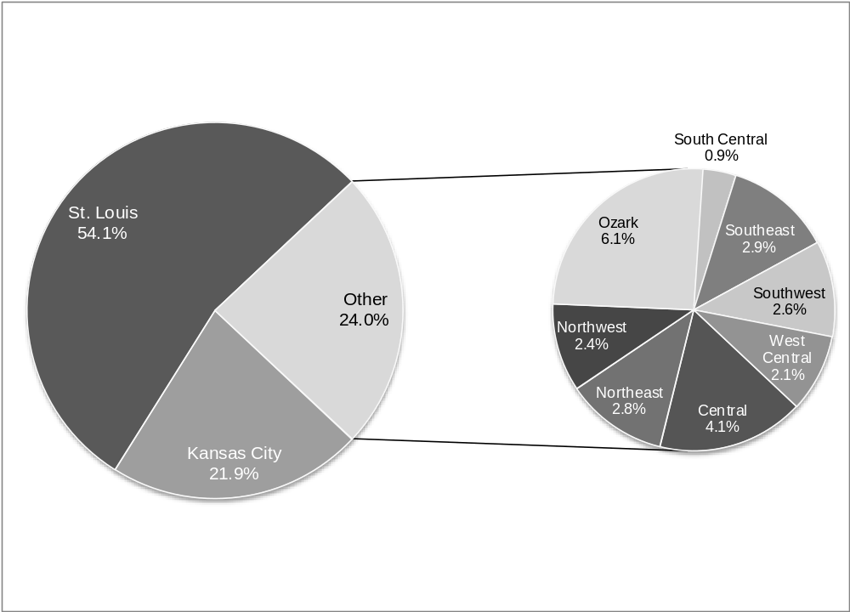
Source: Proprietary School Data System.
Note: Regional classifications are the same used by the Missouri Economic Research and Information Center (see http://www.missourieconomy.org/regional/index.stm).

Percentages are based on the total count of Missouri residents enrolled at Missouri Private Career Schools (MPCS) excluding students whose specific county of origin was unreported*. There were 201 Missouri resident MPCS students whose county of origin was unreported.

Percentages may not sum to 100 due to rounding.
Does not include enrollment at correspondence schools.
*N_{MO x MPCS} = 34,215.

Figure 7B
Percent Enrollment of Missouri Residents by Region of Origin, 2007
Out-of-State Regionally Accredited Degree-Granting Institutions

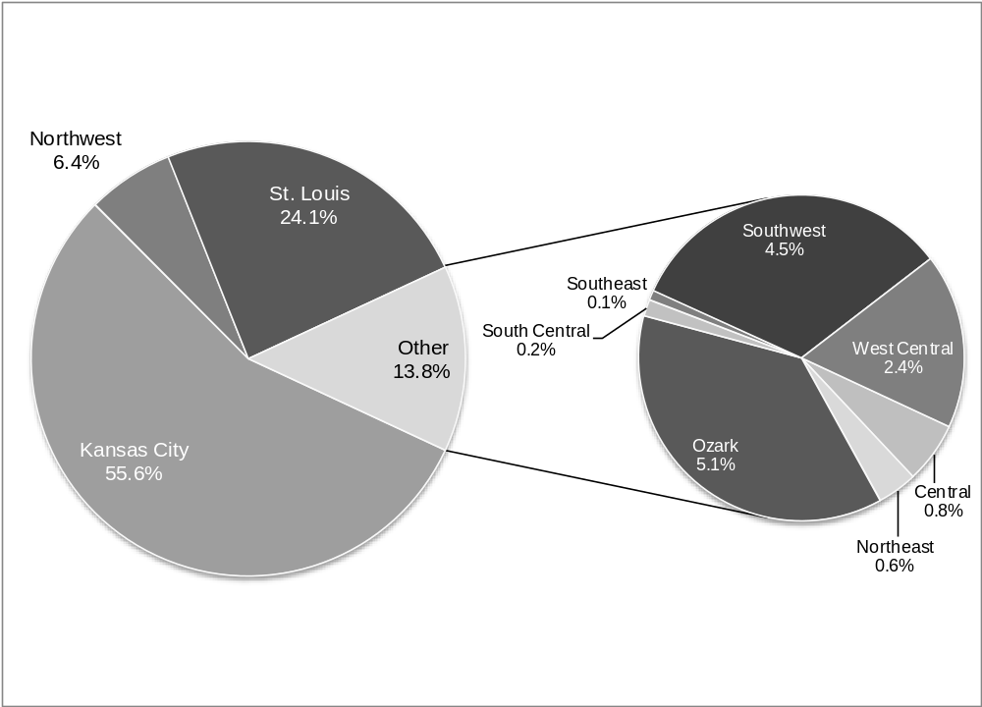

Source: Proprietary School Data System.
Note: Regional classifications are the same used by the Missouri Economic Research and Information Center (see http://www.missourieconomy.org/regional/index.stm).

Percentages are based on the total count of Missouri residents enrolled at Out-of-State Regionally Accredited Degree-Granting Institutions (OOS) excluding students whose specific county of origin was unreported*. There were 24 Missouri resident OOS students whose county of origin was unreported.

Percentages may not sum to 100 due to rounding.
*N_{MO x OOS} = 5,244.

Figure 8A
Regional Distribution of Students Who Attended Schools Outside Their Regions of Origin, 2007
Missouri Private Career Schools

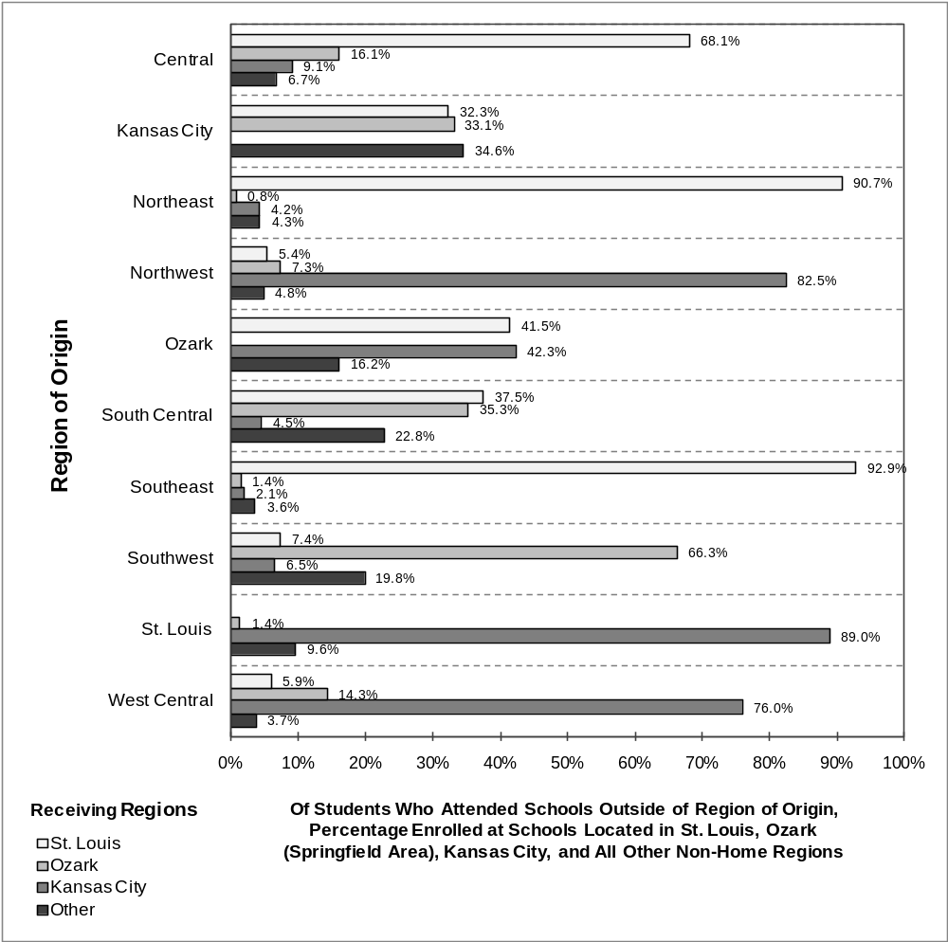

Source: Proprietary School Data System.
Note: Regional classifications are the same used by the Missouri Economic Research and Information Center (see http://www.missourieconomy.org/regional/index.stm).

Percentages are based on the respective total enrollments of ten groups of students (one for each of the ten regions of origin shown above) who enrolled at a school located outside their regions of origin*.

Percentages may not sum to 100 due to rounding.

Does not include enrollment at correspondence schools.
*N_{MPCS} = 4,682.
Figure 8B
Regional Distribution of Students Who Attended Schools Outside Their Regions of Origin, 2007
Out-of-State Regionally-Accredited Degree-Granting Institutions

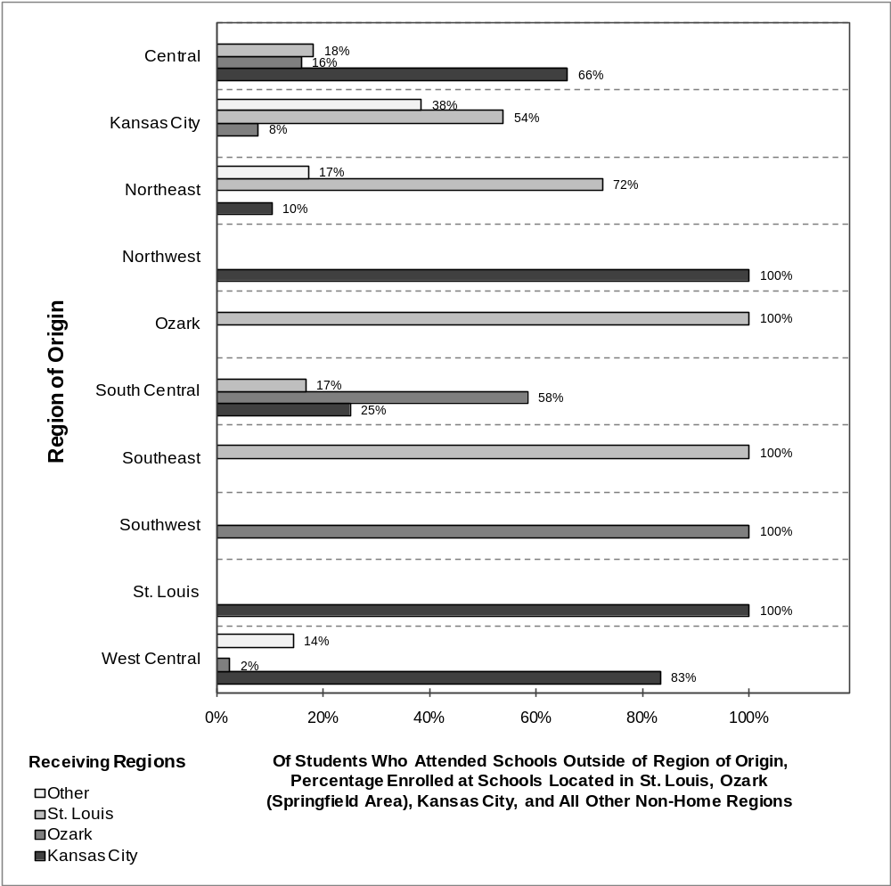

Source: Proprietary School Data System.
Note: Regional classifications are the same used by the Missouri Economic Research and Information Center (see http://www.missourieconomy.org/regional/index.stm).

Percentages are based on the respective total enrollments of ten groups of students (one for each of the ten regions of origin shown above) who enrolled at a school located outside their regions of origin*.

Percentages may not sum to 100 due to rounding.

*N_{OOS} = 417.

Figure 9
Percent Enrollment by In-State/Out-of-State Origin, 2007
Missouri Private Career Schools vs. Out-of-State
Regionally Accredited Degree-Granting Institutions

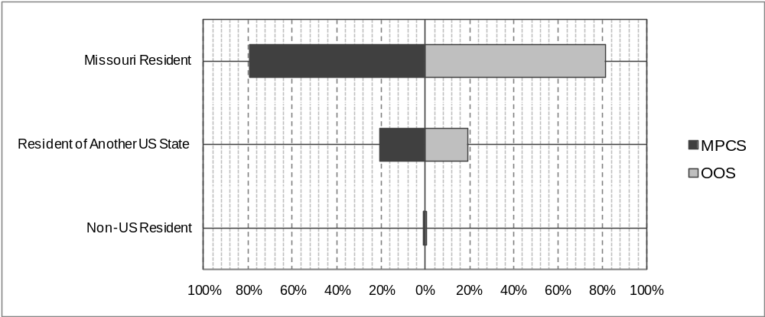

Source: Proprietary School Data System.
 | Missouri Resident | Resident of Another US State | Non-US Resident
MPCS | 79.3% | 20.6% | 0.1%
OOS | 80.9% | 19.0% | 0.1%
Note: MPCS = Missouri Private Career Schools; OOS = Out-of-State Regionally Accredited Degree-Granting Institutions.

Percentages are based on totals for the respective institution types excluding students whose permanent
home state and/or residency status was unreported*. There were 215 MPCS students and 17 OOS students whose permanent home state and/or residency status was unreported.
Percentages may not sum to 100 due to rounding.

Does not include enrollment at correspondence schools.
*N_{MPCS}=43,377; N_{OOS}=6,508.

Figure 10A
Enrollment by Career Cluster, 2007
Missouri Private Career Schools

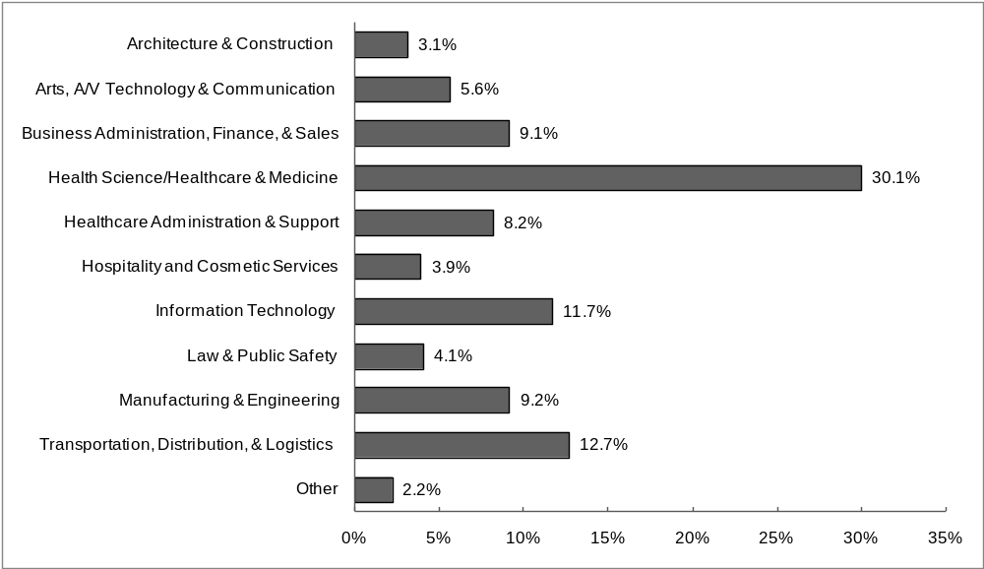

Source: Proprietary School Data System.
Notes: Above classifications refer to the U.S. Department of Education Career Clusters (DOECC), with exceptions documented in Appendix 3.

“Other” refers to programs that could not be classified into any of the clusters shown above and includes general education, remedial / developmental coursework, self-improvement, personal fitness, continuing education, animal grooming and training, and fashion modeling programs.

Percentages are based on total enrollment at Missouri Private Career Schools (MPCS) excluding students whose program of study was unreported**. There were 29 MPCS students whose program of study was unreported.
Percentages may not sum to 100 due to rounding.
Does not include enrollment at correspondence schools.
**N_{MPCS} = 43,563.

Figure 10B
Enrollment by Career Cluster, 2007
Out-of-State Regionally Accredited Degree-Granting Institutions

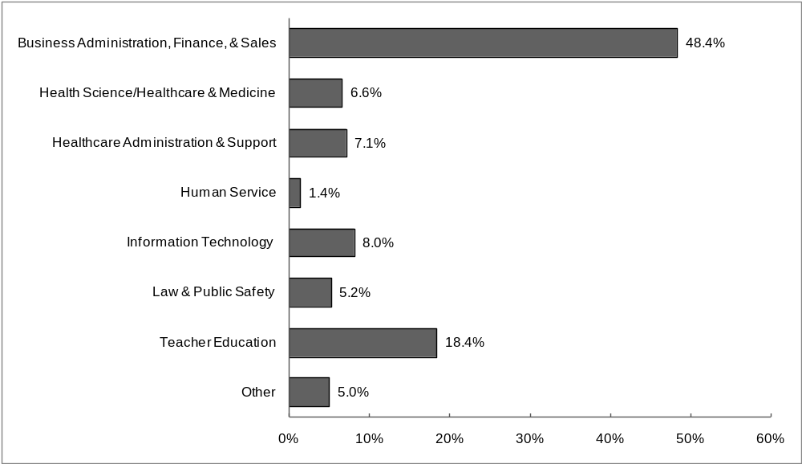

Source: Proprietary School Data System.
Notes: Above classifications refer to the U.S. Department of Education Career Clusters (DOECC), with exceptions documented in Appendix 3.

“Other” refers to programs that could not be classified into any of the clusters shown above and includes general education, remedial / developmental coursework, self-improvement, personal fitness, continuing education, animal grooming and training, and fashion modeling programs.

Percentages are based on total enrollment at Out-of-State Regionally Accredited Degree-Granting Institutions (OOS)**. There were 28 OOS students whose program of study was unreported.
Percentages may not sum to 100 due to rounding.
**N_{OOS} = 6,497.

Figure 11
Vocational Outcomes for Program Graduates, 2007
Missouri Private Career Schools

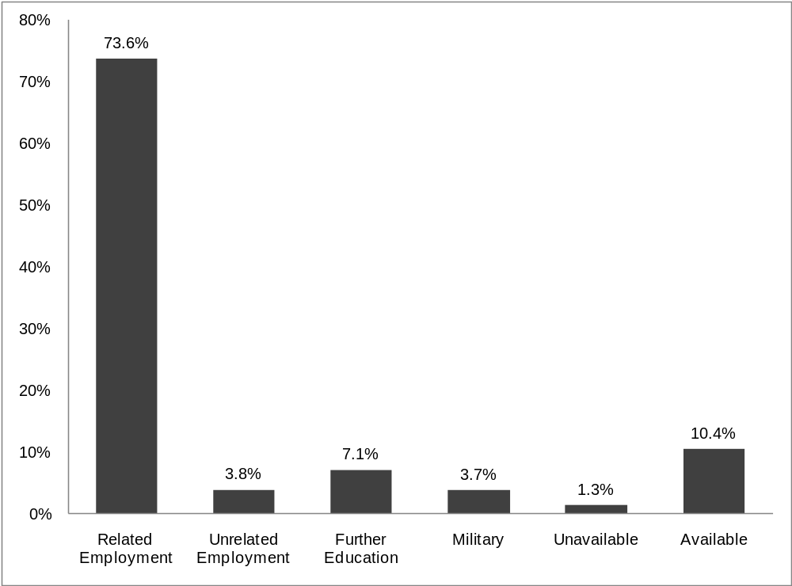

Source: Proprietary School Data System.
Note: Percentages are based on total completions reported by Missouri Private Career Schools (MPCS) excluding students whose specific outcome was unknown*. There were 5,027 MPCS students whose outcome was unknown.
Percentages may not sum to 100 due to rounding.
“Unavailable” refers to graduates who are unavailable for employment.
“Available” refers to graduates who are available for employment but not yet employed.

*N_{MPCS}= 13,545.

Figure 12A
Completions by Career Cluster, 2007
Missouri Private Career Schools

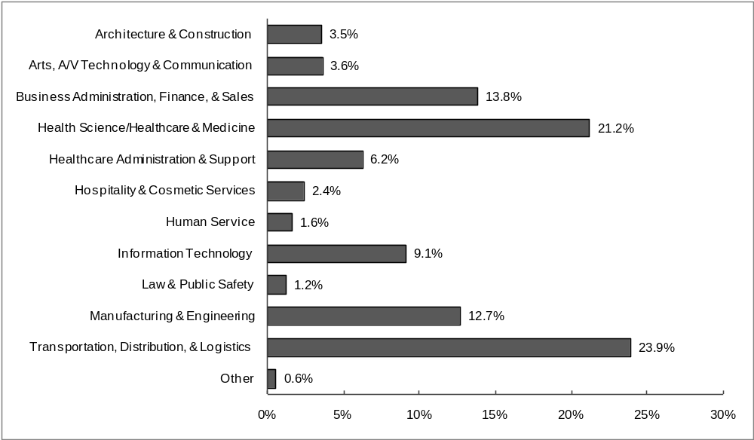

Source: Proprietary School Data System.
Notes: Above classifications refer to the U.S. Department of Education Career Clusters (DOECC), with exceptions documented in Appendix 3.

“Other” refers to programs that could not be classified into any of the clusters shown above and includes general education, remedial / developmental coursework, self-improvement, personal fitness, continuing education, animal grooming and training, and fashion modeling programs.

Percentages are based on total completions reported by Missouri Private Career Schools (MPCS)*. There were no unreported or unassigned programs of study for the students included in this data.
Percentages may not sum to 100 due to rounding.
*N_{MPCS} = 18,572.

Figure 12B
Completions by Career Cluster, 2007
Out-of-State Regionally Accredited Degree-Granting Institutions

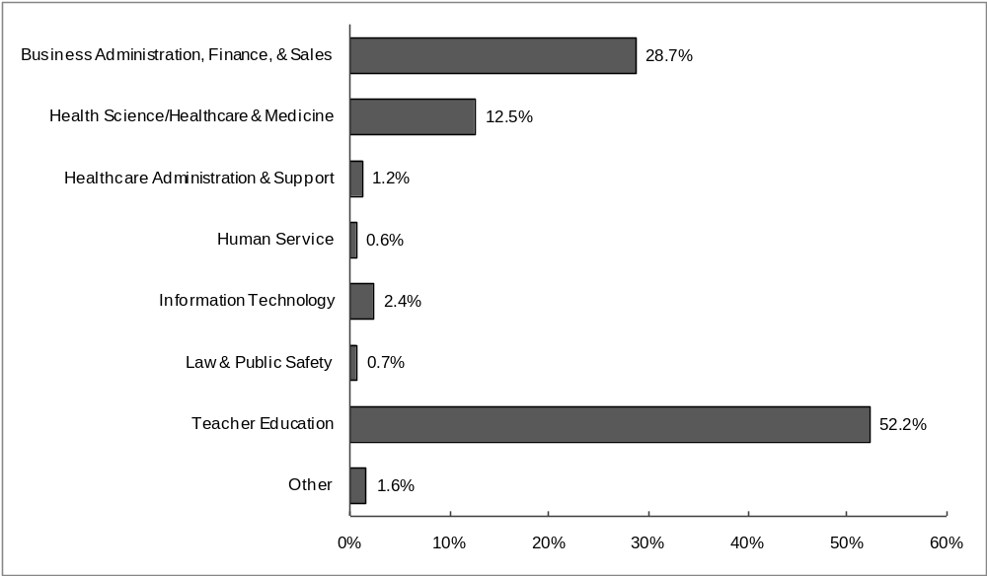

Source: Proprietary School Data System.
Notes: Above classifications refer to the U.S. Department of Education Career Clusters (DOECC), with exceptions documented in Appendix 3.

“Other” refers to programs that could not be classified into any of the clusters shown above and includes general education, remedial / developmental coursework, self-improvement, personal fitness, continuing education, animal grooming and training, and fashion modeling programs.

Percentages are based on total completions reported by Out-of-State Regionally Accredited Degree-Granting Institutions (OOS)**. There were no unreported or unassigned programs of study for the students included in this data.
Percentages may not sum to 100 due to rounding.
*A significant number of these completions (approx. 50%) are in professional development seminars for teachers.
**N_{OOS} = 1,659

Figure 13A
Distribution of Student Financial Aid by Source, 2007
Missouri Private Career Schools

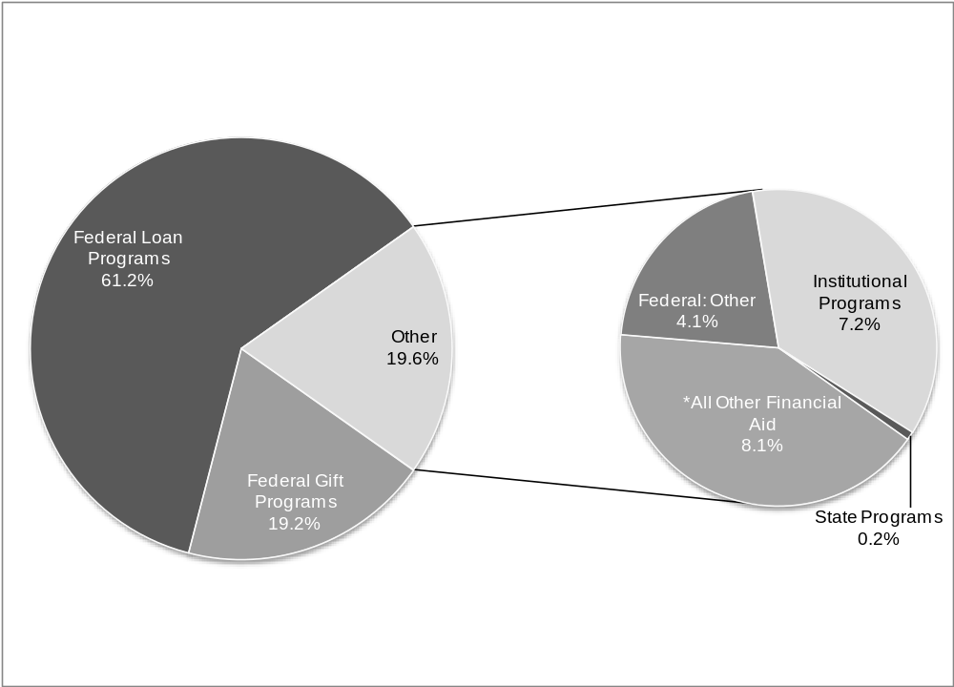

Source: Proprietary School Data System.
Note: Percentages are based on the total monetary amount awarded to students enrolled at Missouri Private Career Schools (MPCS)**.
Percentages may not sum to 100 due to rounding.
*Includes private loans.
**Total Aid Awarded = $240,950,343.
Figure 13B
Distribution of Student Financial Aid by Source, 2007
Out-of-State Regionally Accredited Degree-Granting Institutions

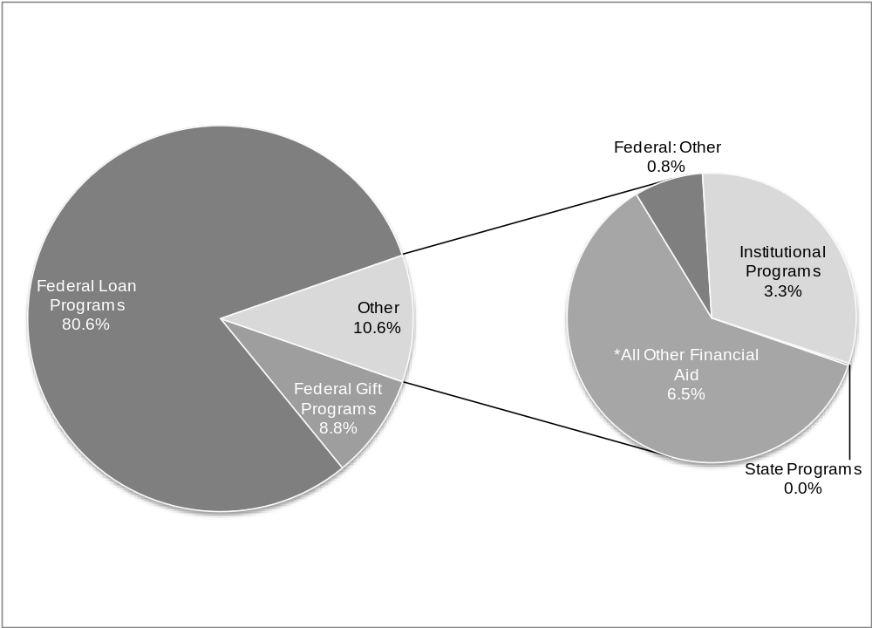

Source: Proprietary School Data System.
Note: Percentages are based on the total monetary amount awarded to students enrolled at Out-of-State Regionally Accredited Degree-Granting Institutions (OOS)**.
Percentages may not sum to 100 due to rounding.
*Includes private loans.

**Total aid awarded = $34,731,902.

Figure 14
Average Loan Amounts by Source, Except Private Loans, 2007
Missouri Private Career Schools vs. Out-of-State
Regionally Accredited Degree-Granting Institutions

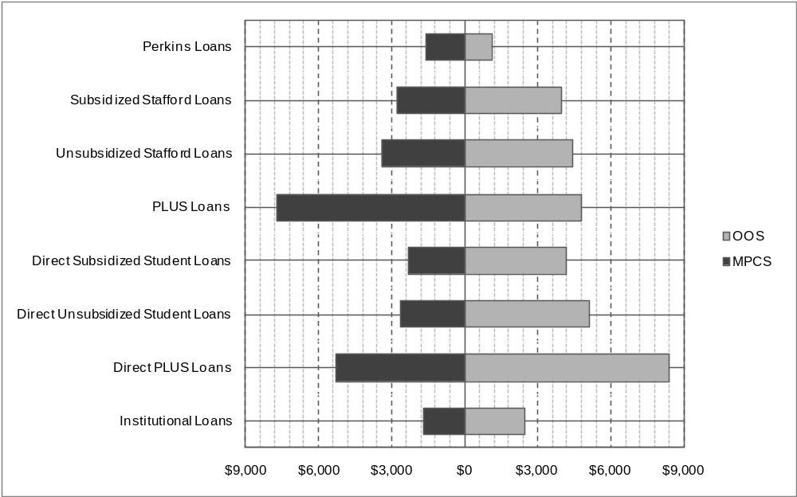

 | Perkins Loans | Subsidized Stafford Loans | Unsubsidized Stafford Loans | PLUS Loans | Direct Subsidized Student Loans | Direct Unsubsidized Student Loans | Direct PLUS Loans | Institution-al Loans
MPCS | $1,766 | $3,073 | $3,360 | $7,304 | $2,232 | $2,536 | $5,536 | $1,863
N_{MPCS} | 650 | 21,247 | 18,704 | 1,803 | 922 | 871 | 134 | 4,465
OOS | $1,116 | $3,960 | $4,436 | $4,799 | $4,198 | $5,113 | $8,359 | $2,438
N_{OOS} | 152 | 2,667 | 2,769 | 37 | 524 | 505 | 2 | 13

Source: Proprietary School Data System.

Note: MPCS = Missouri Private Career Schools; OOS = Out-of-State Regionally Accredited Degree-Granting Institutions.

Averages are calculated by dividing the total dollar amount loaned by each source by the number of students utilizing that source. Totals are summed according to the respective institution types.

Figure 15
Average Financial Aid Disbursements by Source, Other, 2007
Missouri Private Career Schools vs. Out-of-State
Regionally Accredited Degree-Granting Institutions

 | Federal Pell Grants | FSEOG | Federal College Work Study | Other Federal Financial Aid | Advantage Missouri | Non-Missouri State Programs | Institutional Grants / Scholarships | Institutional Jobs | *Other
MPCS | $2,546 | $353 | $2,220 | $4,704 | $4,295 | $4,220 | $1,312 | $2,601 | $4,160
N_{MPCS} | 17,303 | 6,512 | 244 | 1,995 | 26 | 66 | 2,680 | 2,082 | 4,708
OOS | $2,223 | $648 | $779 | $6,258 | N/A | $4,000 | $3,154 | $657 | $6,081
N_{OOS} | 1,303 | 237 | 12 | 44 | N/A | 2 | 351 | 14 | 370
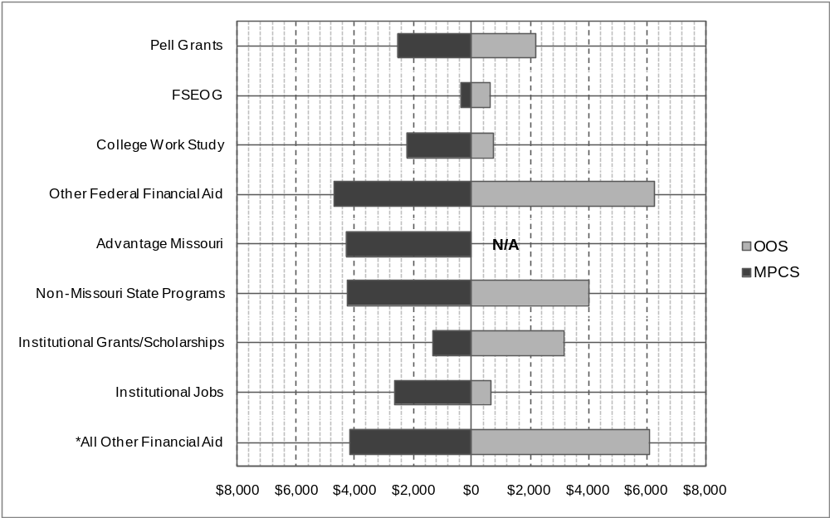

Source: Proprietary School Data System.

Note: MPCS = Missouri Private Career Schools; OOS = Out-of-State Regionally Accredited Degree-Granting Institutions.
FSEOG=Federal Supplemental Education Opportunity Grants
Averages are calculated by dividing the total dollar amount awarded by each source by the number of students utilizing that source. Totals are summed according to the respective institution types.
*Includes private loans.

