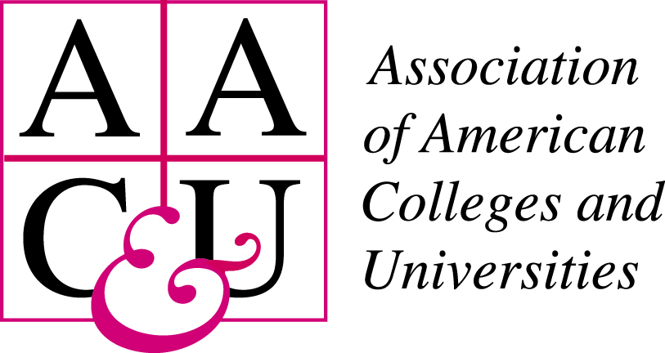

Multi-State Collaborative (MSC) to Advance Quality Student Learning
Refinement Year

Work Plan

The Refinement Year work, based on decisions confirmed by the Steering Committee during the September 23, 2016 Steering Committee conference call, is as follows:

- Rubrics: Critical Thinking, Written Communication, and Quantitative Reasoning are required. Civic Engagement is optional.
- Option 1—Early & Late Collection—Collect at least 50 artifacts (maximum is 150) from first-term students or students who have 15 or fewer credits earned; and collect at least 50 artifacts (maximum is 150) from students who have completed 75% of the credit hours to a degree (at least 45 credit hours at two-year institutions and at least 90 credit hours at four-year institutions)
- Option 2—Late Collection Only—Collect 100 artifacts from students who have completed 75% of credit hours to degree completion (at least 45 credit hours at two-year institutions and at least 90 credit hours at four-year institutions) (maximum of 300).
- Artifacts should not come from group work
- One artifact can be submitted for two value rubrics, such as Written Communication and Critical Thinking, or Criitical Thinking and Quantitative Reasoning.
- Size of artifacts (minimum 3 pages, maximum 25 pages; ideal minimum is 5 pages, ideal maximum is 20 pages)
- Collection periods are fall and spring (see Timeline). Artifacts will be scored for the Refinement Year, not by term.
- A maximum of 10 artifacts from one course can be collected and uploaded.
- Artifacts from the same student for the same rubric from different terms are not permitted.

for Oregon institutions the numbers will be the equivalent quarter hours
for Oregon institutions the numbers will be the equivalent quarter hours

