Don Cullimore News Bureau Contacts Cathy Thogmorton

Phone: (660) 248-6238 Phone: (660) 248-6391

E-mail: dcullimo@centralmethodist.edu E-mail: cthogmor@centralmethodist.edu

FOR RELEASE: March 11, 2011 – To retrieve release electronically, go to www.centralmethodist.edu or www.sfccmo.edu

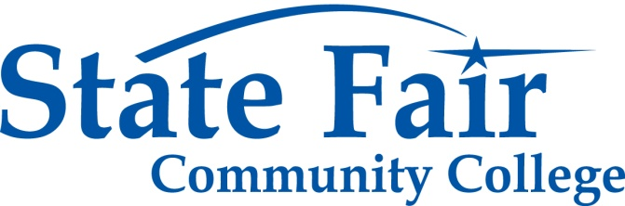

CONTACT: Dana M. Kelchner
Director of Marketing and Communications
State Fair Community College
3201 W. 16th St.
Sedalia, MO 65301-2199
(660) 596-7250 – Direct Line
(660) 596-7335 – Fax
dkelchner@sfccmo.edu
www.sfccmo.edu

CMU and SFCC Receive $99,000 ACE Grant
Funding for Program to Increase Access to College for Low-Income Residents

FAYETTE & SEDALIA—Central Methodist University and State Fair Community College have received a joint $99,000 grant from the Missouri Department of Education to implement a program to increase the number of low-income Missourians able to attend and succeed in college.
The one-year grant provides start-up funds for CMU and SFCC to develop a project called Advantages of College Education (ACE). The project will provide college access services to more than 53,000 students and residents throughout SFCC’s 14-county service region.
Beginning April 1, ACE will conduct a variety of activities designed to help boost college attendance rates and to develop relationships with high school staff members to further the goals of the grant.
Pat Gillman, SFCC College Opportunities director, said every community and school district has different needs.
“The focus of this project is to identify those activities which will have the most benefit for each unique community,” she said. “We’ll assess those needs at the beginning of the project and continue to collect data so we can make improvements throughout the year.”
The primary activity will be to provide information on financial aid and completion of the Free Application for Federal Student Aid (FAFSA). Advisors will be available to help individual students and parents and nontraditional students, and to offer workshops at high schools and community centers.
Other activities will include:
• Workshops and assistance for A+ program coordinators and the Adult Basic Education/GED/English as a Second Language program
• Creation of a resource library warehouse; an alumni mentor program; and an adult stop-out program to contact students who stopped attending college and provide information to help get them back in school
• Stipends for high schools to help pay for meals, transportation, printing, and coordination so students can attend SFCC’s annual College Fair and Career Day
• Promoting college visits and marketing the ACE program
• A middle school outreach program to help make students and parents aware of the benefits of a college education
• Informational workshops for high school counselors, faculty and A+ coordinators
SFCC and CMU already provide a 2+2 degree program to students in SFCC’s 14-county service area, which provides a seamless transition for students who want to complete their four-year degrees.
Founded in 1854, Central Methodist is the only United Methodist Church-related university in Missouri, and welcomes qualified men and women of all faiths and from diverse backgrounds. Its wooded, historic campus hosts a faculty of teachers, mentors, and scholars dedicated to providing extraordinary attention to the individual learner. With offerings ranging from high-school dual credit to graduate studies and a total enrollment in excess of 5,100, its liberal arts and pre-professional programs are centered on a character core that has twice brought Central Methodist national recognition for its leadership in character education. In recent years the University has attracted significant challenge grants regionally from the Mabee Foundation and nationally from the Kresge Foundation to help build a $15 million Student and Community Center on the academic quadrangle, to fund $5 million in major upgrades to its athletic facilities, and to compete a $5.4 million renovation of a historic campus building.
-- 30 --
(News Releases March 2011/CMU-SFCC Receive ACE Grant)

